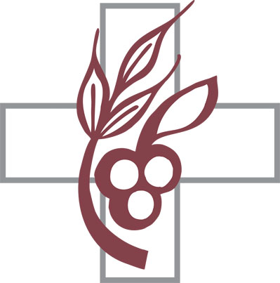
September~ 2022
Lamb of God Ev Lutheran Church & Academy
1414 So Washington Street, Papillion, Ne 68046

SUNDAY | MONDAY | TUESDAY | WEDNESDAY | THURSDAY | FRIDAY | SATURDAY
 |  |  |  | 1 | 2  Tim Stohlmann BD | 3 Men’s Bible study 8:30 am  Bible study 4:30 pm  Divine Service 5:30
4 Divine Service  9:00 am  Sunday School  10:30 | 5  Steve & Stephanie  Sleeper Annv | 6  Matthew Rock BD  Randy Bilbrey BD | 7  Tesser Tedder | 8  Board of Education at 6:30 pm  Vincent & Erika Shaw Annv | 9  Phillip Schroeder BD | 10 Men’s Bible study 8:30 am  Sisters in Christ  Meet at 10:00 am  Bible Study 4:30 pm  Divine Service 5:30
11 Divine Service  9:00 am  Sunday School  10:30  Kids SS class 10:15 | 12 | 13  Board of Properties at 6:00 pm  Kade Rubenthaler BD | 14 | 15 | 16  Ryan Meyer BD  Mike & Cheryl Lindblom Annv | 17 Men’s Bible study 8:30 am  Bible Study 4:30  Divine service 5:30
18 Divine Service  9:00 am  Sunday School  10:30 | 19  Phillip & Nancy Schroeder Annv  Vincent Shaw BD | 20  Parish Council at  6:30 pm  Tyler Schilling BD | 21 | 22 | 23  Allan & Barb Buelt Annv | 24 Men’s Bible study 8:30 am  Bible Study 4:30pm  Divine Service 5:30
25 Divine Service  9:00 am  Sunday School  10:30  kids SS at 10:15 | 26 | 27 | 28  Aaron Sinnett BD | 29  Erich & Breonda Ziegler Annv | 30

